Accessing Professional Development within CA Wonders
- Login to ConnectED
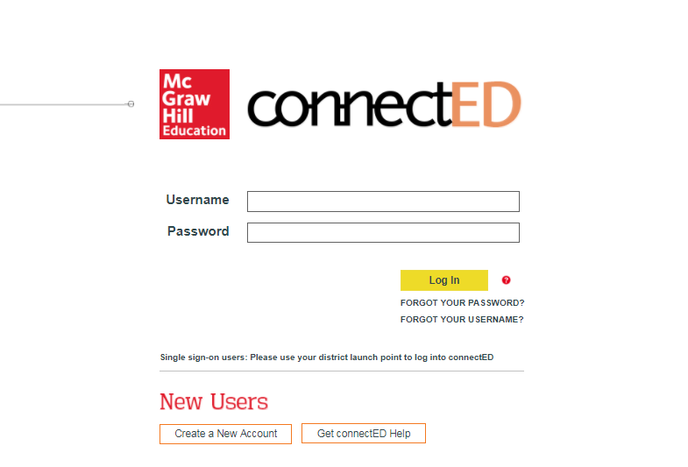

- Open your Teacher Edition
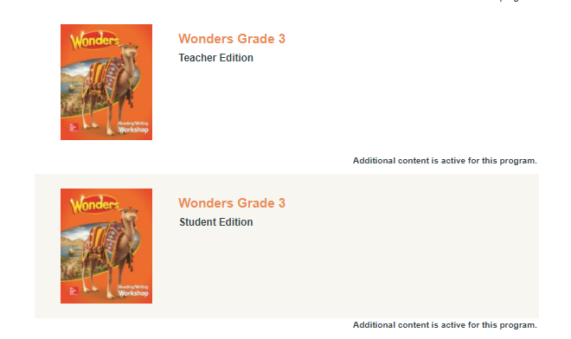

- Click Resources: Professional Development or the Professional Development icon.
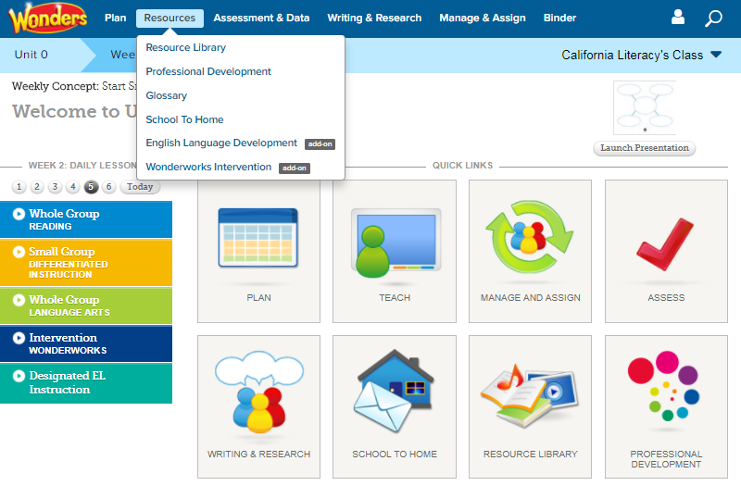

- The following tabs are available:
- Overview – includes the Professional Learning Environment for teachers, administrators, and coaches – a guided tour of CA Wonders resources
- Classroom Videos
- Coach Videos
- Digital Help
- English Learners

