 | Teacher’s Edition Package 10 books  (Unit 1-10)  ISBN: 0021427542 |  | Reading Writing Workshop Big Book Package  11 big books  ISBN: 0021392625
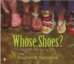 | Literature Big Book Package  32 big books  ISBN: 970021193363 |  | Reading Writing Workshop Package  1 per student  ISBN: 9780021428458
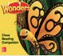 | Close Reading Companion  1 per student  ISBN: 9780021307463 | 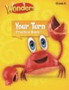 | Your Turn Practice Book  1 per student  ISBN: 9780076772131
 | Decodable Reader Package  24 per teacher  ISBN: 9780021392575 | 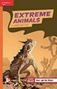 | Leveled Readers- Approaching Level  60 books  ISBN: 9780021193349
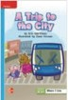 | Leveled Readers - On Level  60 Books  ISBN: 9780021194904 | 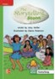 | Leveled Readers - Beyond Level  60 books  ISBN: 9780021193370
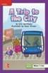 | Leveled Readers - ELL  60 books  ISBN: 9780021194643 |  | Visual Vocabulary Cards ISBN: 9780021193684
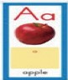 | Sound Spelling Large Cards  1 set  ISBN: 0076768090 |  | Interactive Read Aloud Cards ISBN: 9780021193691

 | READING WONDERS RETELLING CARDS  ISBN: 0021193614 |  | READING WONDERS PICTURE PHOTO CARDS G  ISBN: 0021195595
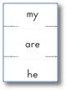 | High-Frequency Word Cards ISBN: 9780021192908 | 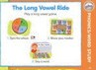 | Workstation Activity Cards ISBN: 9780021192939
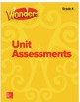 | Unit Assessment: SBAC ISBN: 0021339732 | 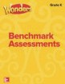 | Benchmark Assessments: SBAC ISBN: 0021330867
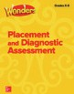 | Placement & Diagnostic Assessment: K-6 ISBN: 0076779548 | READING WONDERS TEACHING POSTERS CHARTS GRADE K  ISBN: 0021195293
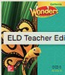 | English Learners Teacher’s Edition  1 book  ISBN: 0021314519 | 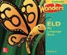 | English Learners My Language Book  TBD  ISBN: 002131134X
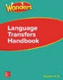 | Language Transfer Book Grades K-6  ISBN: 9780021391103 | 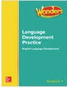 | English Learners Language Development Practice BLM  Grades K-1  ISBN: 9780021314232
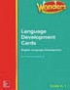 | English Learners Language Development Cards Grades K-1  ISBN: 9780021303595 | 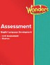 | English Learners Assessment ISBN: 9780021311378

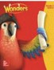 | Teacher’s Edition Package  6 Books  ISBN: 0021427550 | 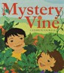 | Literature Big Books Package ISBN: 9780021195244
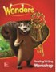 | Reading Writing Workshop Big Book Package  6 Big Books  ISBN: 9780021274994 |  | Reading Writing Workshop  1 per student  ISBN: 0021428468
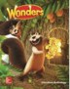 | Literature Anthology  1 per student  ISBN: 0021392595 | 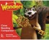 | Close Reading Companion 1 per student  ISBN: 9780021305216
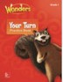 | Your Turn Practice Book  1 per student  ISBN: 9780076787128 |  | Decodable Readers Package  24 per teacher  ISBN: 9780021392582
 | Leveled Readers – Approaching Level  36 books  ISBN: 9780021195619 |  | Leveled Readers - On-Level  36 books  ISBN: 9780021195770
 | Leveled Readers - Beyond Level  36 books  ISBN: 9780021196623 |  | Leveled Readers - ELL  36 books  ISBN: 9780021195220
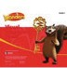 | Visual Vocabulary Cards ISBN: 9780021195374 |  | Sound Spelling Large Cards ISBN: 0076768090

 | Reading Wonders Photo Cards Grades K-2  ISBN: 0021195595 |  | Reading Wonders leveled Reader Lesson Cards Grade 1  ISBN: 0021292051
 | Reading Wonders leveled Reader Lesson Cards  ISBN: 0021292051 |  | Wonders Retelling Cards  ISBN: 0021195382
 | Interactive Read Aloud Cards ISBN: 9780021195398 | 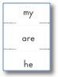 | High-Frequency Word Cards ISBN: 9780021195589
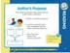 | Workstation Activity Cards Package ISBN: 9780021195213 | 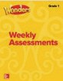 | Weekly Assessment ISBN: 0021302049
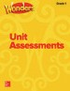 | Unit Assessment: SBAC ISBN: 0021361959 | 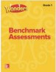 | Benchmark Assessments: SBAC ISBN: 0021308764
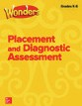 | Placement & Diagnostic Assessment Grades K-6  ISBN: 0076779548 | Wonders Classroom Tradebook Library  24 Titles

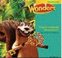 | English Learners Teacher’s Edition  1 book  ISBN: 0021303649 | 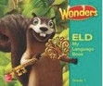 | English Learners My Language Book  TBD  ISBN: 0021304130
 | Language Transfer Book ISBN: 9780021391103 | 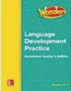 | English Learners Language Development Practice BLM  ISBN: 9780021314232
 | EL Visual Vocabulary Cards ISBN: 9780021399031 | 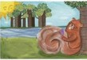 | English Learners Retelling Cards ISBN: 9780021327720
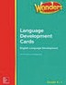 | English Learners  Language Development Cards ISBN: 9780021303595 | 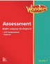 | English Learners Assessment ISBN: 9780021309993

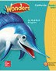 | Teacher’s Edition Package  6 books  ISBN: 0021427585 | 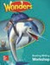 | Reading Writing Workshop  1 per student  ISBN: 0021304920
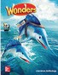 | Literature Anthology  1 per student  ISBN: 9780021340989 | 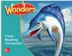 | Close Reading Companion  1 per student  ISBN: 9780021305995
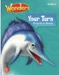 | Your Turn Practice Book  1 per student  ISBN: 9780076807215 |  | Decodable Reader Package  6 per teacher  ISBN: 9780076661718
 | Leveled Readers - Approaching Level  36 books  ISBN: 9780021186723 |  | Leveled Readers - On-Level  36 books  ISBN: 9780021190515
 | Leveled Readers - Beyond  36 books  ISBN: 9780021190522 |  | Leveled Readers - ELL  36 books  ISBN: 9780021186983
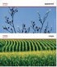 | Visual Vocabulary Cards ISBN: 9780021189250 | 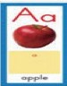 | Sound Spelling Large Cards ISBN: 0076768090
 | Interactive Read Aloud Cards ISBN: 9780021187775

 | Workstation Activity Cards Package ISBN: 9780021186990 | 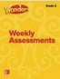 | Weekly Assessment ISBN: 0021302324
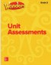 | Unit Assessment: SBAC ISBN: 002130453X | 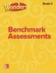 | Benchmark Assessments: SBAC ISBN: 002131571X
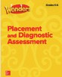 | Placement & Diagnostic Assessment Grades K-6  ISBN: 0076779548 | Wonders Classroom Tradebook Library  24 Titles
Reading Wonders leveled Reader Lesson Cards Grade 2
ISBN: 002129206X

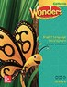 | English Learners Teacher’s Edition  1 book  ISBN: 9780021311637 | 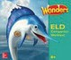 | English Learners Companion Worktext Expanding/Bridging  TBD  ISBN: 9780021303465
 | Language Transfer Book Grades K-6 ISBN: 9780021391103 | 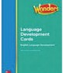 | English Learners Language Development Practice BLM Grades 2-3  ISBN: 9780021312689
 | English Learners Visual Vocabulary Cards ISBN: 9780021380879 | 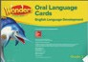 | English Learners Oral Language Cards ISBN: 9780021317462
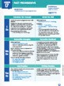 | English Learners Language Development Cards Grades 2-3  ISBN: 9780021331369 |  | English Learners Companion Worktext  Emerging  TBD  6 book per Emerging English Learner  ISBN: 9780021303465
 | English Learners Assessment ISBN: 0021316199

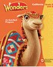 | Teacher’s Edition Package 6 books  ISBN: 0021427593 | 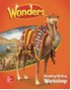 | Reading Writing Workshop  1 per students  ISBN: 0021331715
 | Literature Anthology  1 per students  ISBN: 9780021341740 | 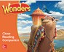 | Close Reading Companion  1 per student  ISBN: 0021329410
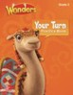 | Your Turn Practice Book  1 per student  ISBN: 9780076774678 |  | Leveled Readers - Approaching 36 books  ISBN: 9780021191956
 | Leveled Readers - On-Level 36 books  ISBN: 9780021186235 |  | Leveled Readers - Beyond 36 books  ISBN: 9780021186242
 | Leveled Readers - ELL 36 books  ISBN: 9780021185801 |  | Visual Vocabulary Cards ISBN: 9780021187829
Reading Wonders - Leveled Reader Lesson Cards Grade 3
ISBN: 0021292078
 | Workstation Activity Cards Package ISBN: 9780021191642 | 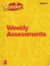 | Weekly Assessment ISBN: 002131943X

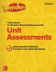 | Unit Assessment: SBAC ISBN: 0021320098 | 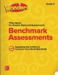 | Benchmark Assessments: SBAC ISBN: 0021313202
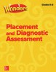 | Placement & Diagnostic Assessment Grades K-6  ISBN: 0076779548 | Wonders Classroom Tradebook Library  24 Titles

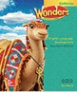 | English Learners Teacher’s Edition  1 book  ISBN: 0021315531 | 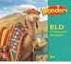 | English Learners Companion Worktext - Expanding/Bridging  TBD  ISBN: 0021315485
 | Language Transfer Book Grades K-6  ISBN: 9780021391103 | 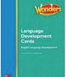 | English Learners Language Development Practice BLM Grades 2-3  ISBN: 9780021312689
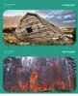 | English Learners Visual Vocabulary Cards ISBN: 9780021328550 | 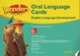 | English Learners Oral Language Cards ISBN: 9780021303007
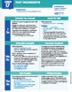 | English Learners Language Development Cards Grades 2-3  ISBN: 9780021331369 |  | English Learners Companion Worktext  6 per Emerging English Learner  ISBN: 0021315485
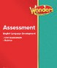 | English Learners Assessment ISBN: 9780021311156 | Reading Wonders English Learners Oral Language Cards Grade 3  ISBN: 002130300

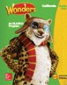 | Teacher’s Edition Package  6 books  ISBN: 21454361 | 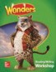 | Reading Writing Workshop  1 per student  ISBN: 0021306451
 | Literature Anthology  1 per student  ISBN: 9780021417377 | 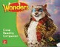 | Close Reading Companion  1 per student  ISBN: 9780021308736
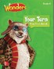 | Your Turn Practice Book  1 per student  ISBN: 0076785130 |  | Leveled Readers - Approaching  36 books  ISBN: 9780021187478
 | Leveled Readers - On-Level  36 books  ISBN: 9780021192182 |  | Leveled Readers - Beyond  36 books  ISBN: 9780021186006
 | Leveled Readers - ELL  36 books  ISBN: 9780021186013 |  | Visual Vocabulary Cards ISBN: 9780021186976
 | Reading Wonders - Leveled Reader Lesson Cards Grade 4  ISBN: 0021292086 |  | Workstation Activity Cards Package ISBN: 9780021186952
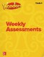 | Weekly Assessment ISBN: 0021324298 | 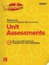 | Unit Assessment: SBAC ISBN: 0021324786

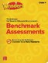 | Benchmark Assessments: SBAC ISBN: 0021324646 | 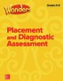 | Placement & Diagnostic Assessment Grades K-6  ISBN: 0076779548
Wonders Classroom Tradebook Library
24 Titles

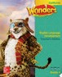 | English Learners Teacher’s Edition Grade 4  1 book  ISBN: 0021329052 | 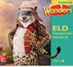 | English Learners Companion Worktext Expanding/Bridging  TBD  ISBN: 0021320551
 | Language Transfer Book ISBN: 9780021391103 | 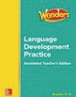 | English Learners Language Development Practice BLM  Grades 4-6  ISBN: 9780021315116
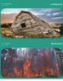 | English Learners Visual Vocabulary Cards ISBN: 9780021314218 | 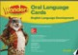 | English Learners Oral Language Cards ISBN: 9780021305681
 | English Learners Companion Worktext Emerging  6 per Emerging English Learners  TBD  ISBN: 0021320551 | 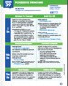 | English Learners Language Development Cards Grades 4-6  ISBN: 9780021306794
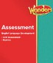 | English Learners Assessment ISBN: 9780021328130

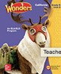 | Teacher’s Edition Package  6 books  ISBN: 0021454469 | 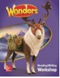 | Reading Writing Workshop  1 per student  ISBN: 002133031X
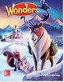 | Literature Anthology  1 per student  ISBN: 0021417873 | 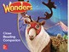 | Close Reading Companion 1 per student  ISBN: 9780021310258
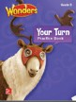 | Your Turn Practice Book  1 per student  ISBN: 0076779246 |  | Leveled Readers - Approaching 36 books  ISBN: 9780021193950
 | Leveled Readers - On-Level 36 books  ISBN: 9780021193967 |  | Leveled Readers - Beyond 36 books  ISBN: 9780021193707
 | Leveled Readers - ELL 36 books  ISBN: 9780021192977 | 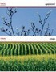 | Visual Vocabulary Cards ISBN: 9780021192304
 | Reading Wonders - Leveled Reader Lesson Cards Grade 5  ISBN: 0021292094 |  | Workstation Activity Cards Package ISBN: 9780021193257
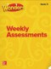 | Weekly Assessment ISBN: 0021317224 | 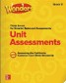 | Unit Assessment: SBAC ISBN: 0021307725

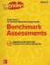 | Benchmark Assessments: SBAC ISBN: 0021323232 | 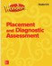 | Placement & Diagnostic Assessment Grades K-6  ISBN: 0076779548
Wonders Classroom Tradebook Library
24 Titles

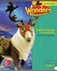 | English Learners Teacher’s Edition  1 book  ISBN: 0021306680 | 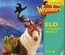 | English Learners Companion Worktext - Expanding/Bridging  1 book per English Learner  ISBN: 0021318719
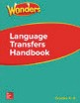 | Language Transfer Book Grades K-6  ISBN: 9780021391103 | 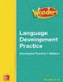 | English Learners Language Development Practice BLM Grades 4-6  ISBN: 9780021315116
 | English Learners Visual Vocab Cards ISBN: 9780021313426 | 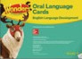 | English Learners Oral Language Cards ISBN: 9780021327713
 | English Learners Companion Worktext  Emerging  6 book per Emerging English Learner | 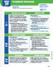 | English Learners Language Development Cards Grades 4-6  ISBN: 9780021306794
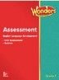 | English Learners Assessment ISBN: 9780021317318

