**McGraw-Hill *California Wonders* and *California Maravillas*!**

1. **We had concerns particularly in third grade about the perceived lack of cultural responsiveness in Wonders.  You asked that we ask you about any pieces we think are missing.  Maybe you can point out the culturally responsive pieces in Wonders especially in third grade.**

Reading Wonders prides itself on exceeding the requirements for equal opportunity or representation in its program. We believe that all children should be represented with the opportunities to engage in worthwhile tasks and have their materials be free from cultural, ethnic or gender bias. Reading Wonders displays males and females from various ethnic backgrounds in all types of environments, avoiding stereotypes. Students of all backgrounds will be able to relate to the text.

The literature selections and accompanying images that appear throughout McGraw-Hill Reading Wonders program reflect diversity and promote respect for people of different ethnicities, genders, races, and ages, as well as socioeconomic and ability groups. All selections chosen for inclusion in the program were evaluated by a team of editors, illustrators, program authors, literature consultants, multicultural consultants, teacher and student reviewers. This team established the criteria used in the literature review process and often offered their own suggestions for selections to be included in the program. The most current census data was used to help the team create a multiculturally balanced program. Award-winning children's authors and illustrators were commissioned to create new selections that reflected this goal. In selecting literature and creating student materials, the Reading team at McGraw-Hill focused on producing components free from bias and stereotypes that accurately portray the perspectives of all diverse groups.

In the first two units alone of the 3rd grade anthology you see a wide array of ethnic backgrounds and cultures represented from a story about a young girl who is adjusting to her move from America to Korea, to a story about a famous African-American inventor, to a Mexican folktale.

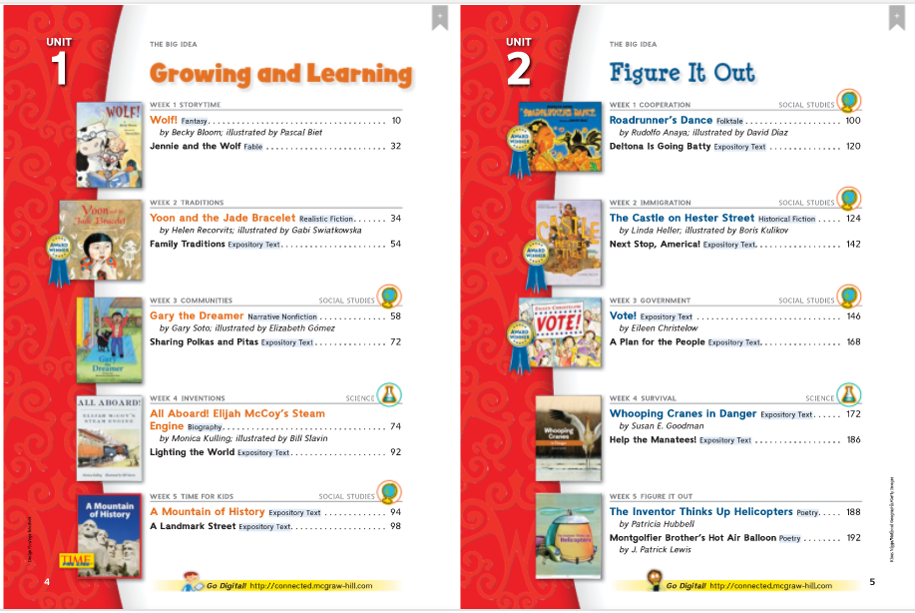

Please see attached document for additional support.

1. **We also noticed that the TE page numbers do NOT match with the weekly overview.  Will that be corrected?**

Could they please give us examples so that we can research the issue?

1. **We also saw that questions are posed for students.  However, possible responses are not listed.  Will that be changed?**

There are annotated versions of many resources of most resources on line in the teacher resources section.

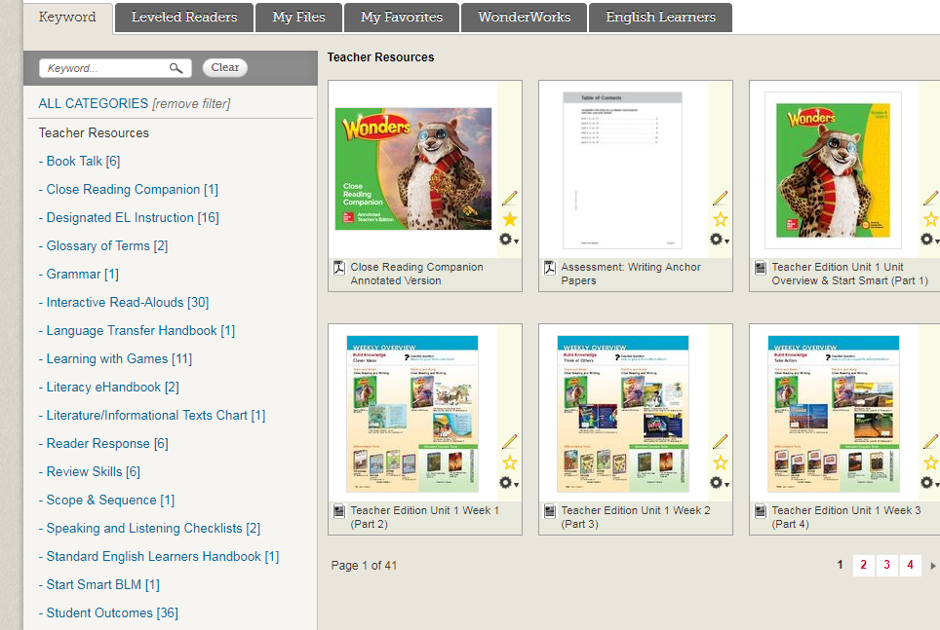

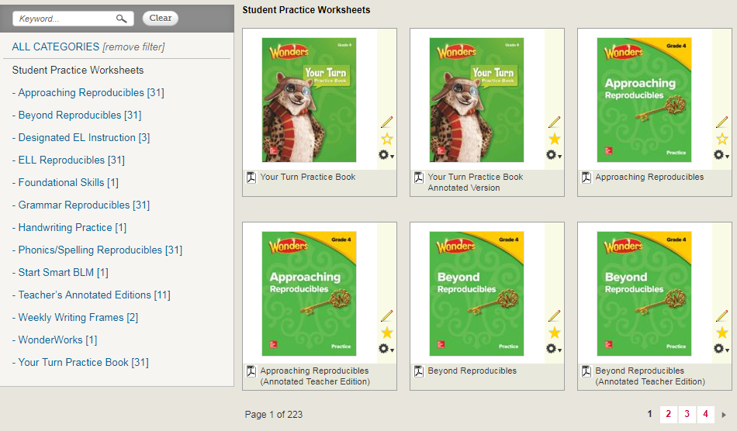

In the teacher’s guide you will see answers and prompts at the point of use for most questions and discussions.

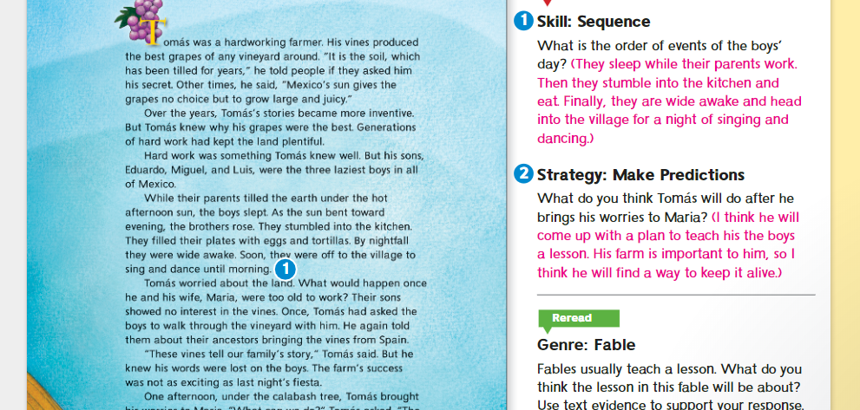 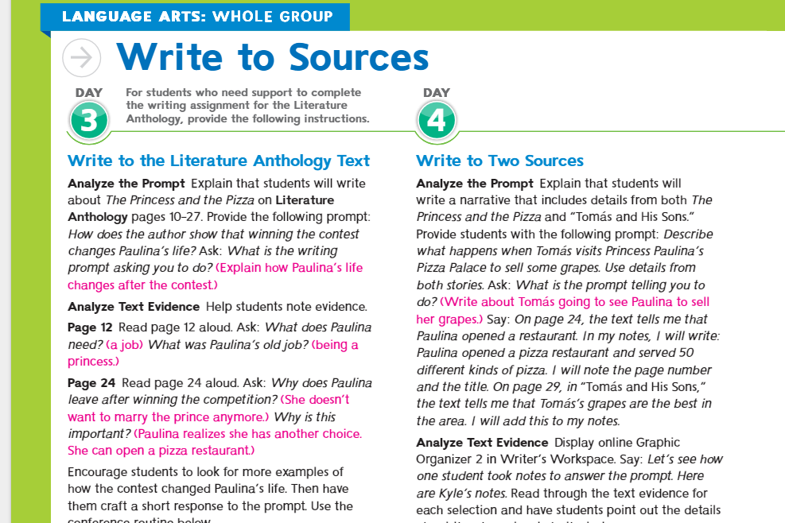

If there are additional places where responses are not provided in the ATE or not listed in the TE, please give examples so we can point to where they are or the reason for them not being included.

1. **We’d like access to short, nonfiction articles.  Does Wonders have that but we have yet to discover it?**

Wonders was created to ensure student understand that we can explore a topic using various types of text and genres for a more dynamic experience with text.

Short nonfiction articles and information text is found in every unit in Wonders. They can be found in the Reading/Writing Workshop and the Literature Anthology. There are even icons that alert teachers and students if they are science and social studies related. Let’s take a look at grade 4.

In the Reading Writing Workshop book, Unit 1 has an expository article about the changing earth and a **Times for Kids** article about businesses who help around the world.

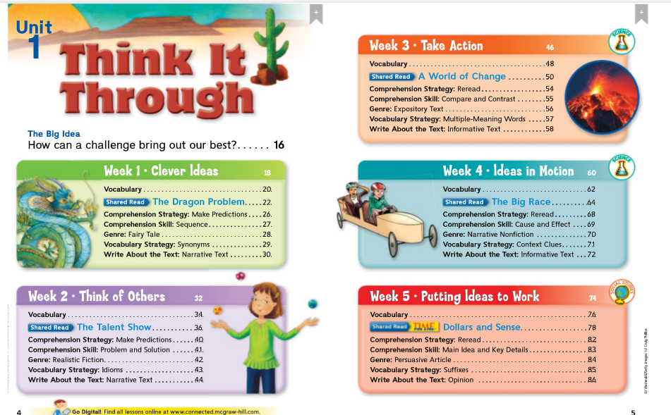

In the Literature anthology, you will see corresponding text of the same genres allowing students opportunities to apply what they learned in the RWW.

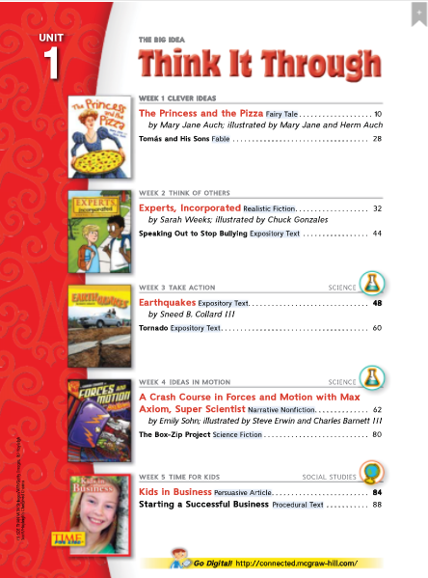

For additional practice, teachers will also find matching and connected text in the Your Turn practice book. The article below is a from Unit 1, week 3 and is correlated with the reading for that week.

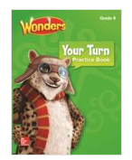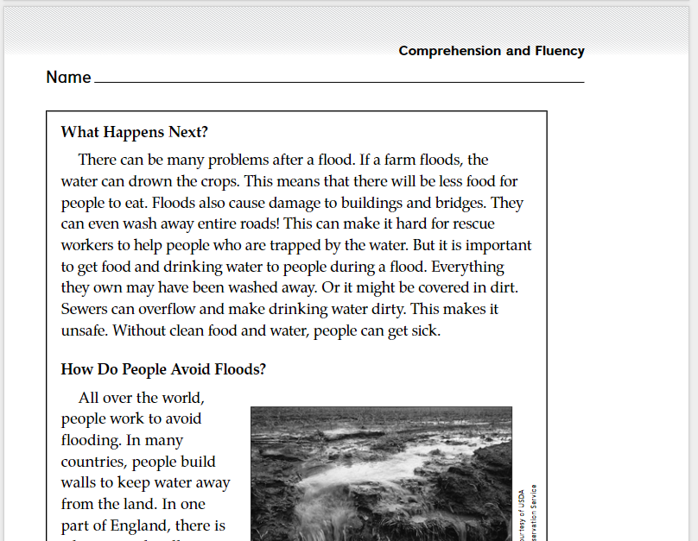

Unit 2 has two expository text s.

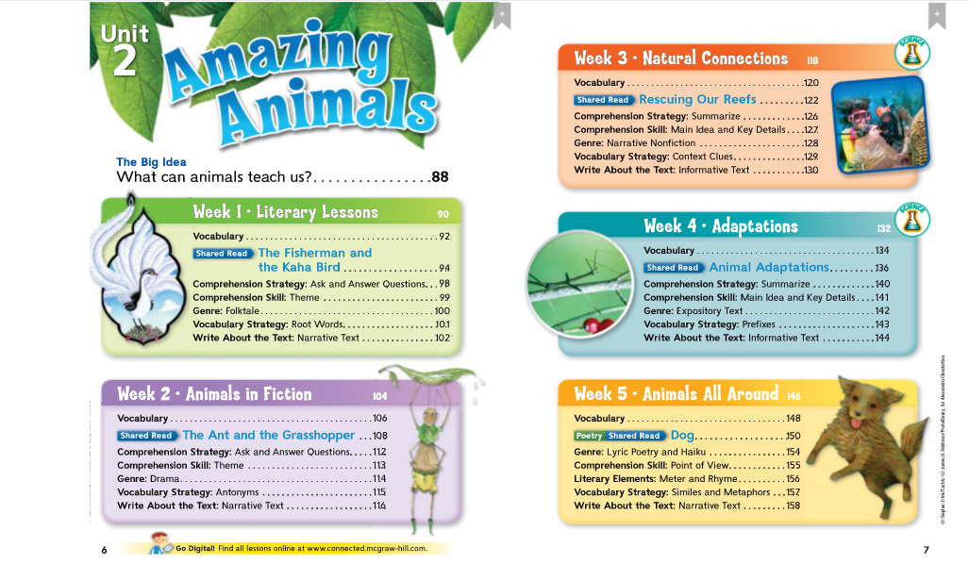

Unit 5 has two a biography, expository text and an Information article in the Time for Kids lesson.

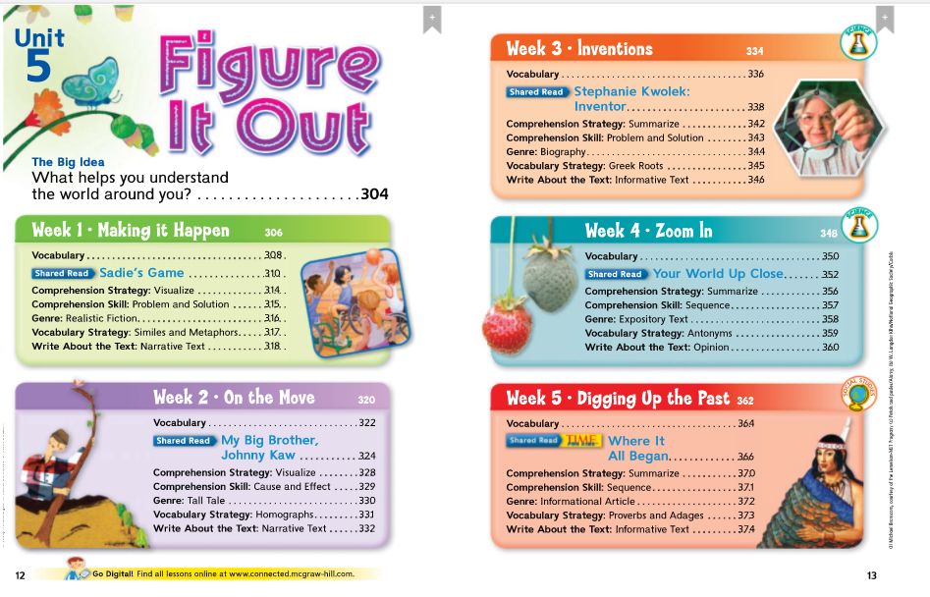

There are even additional ***Time for Kids*** articles available digitally that are interactive and engaging.

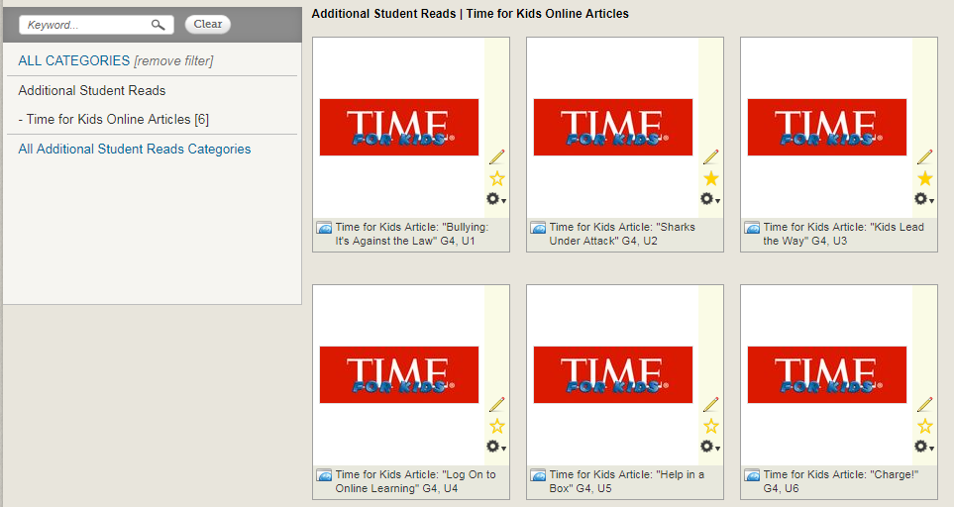

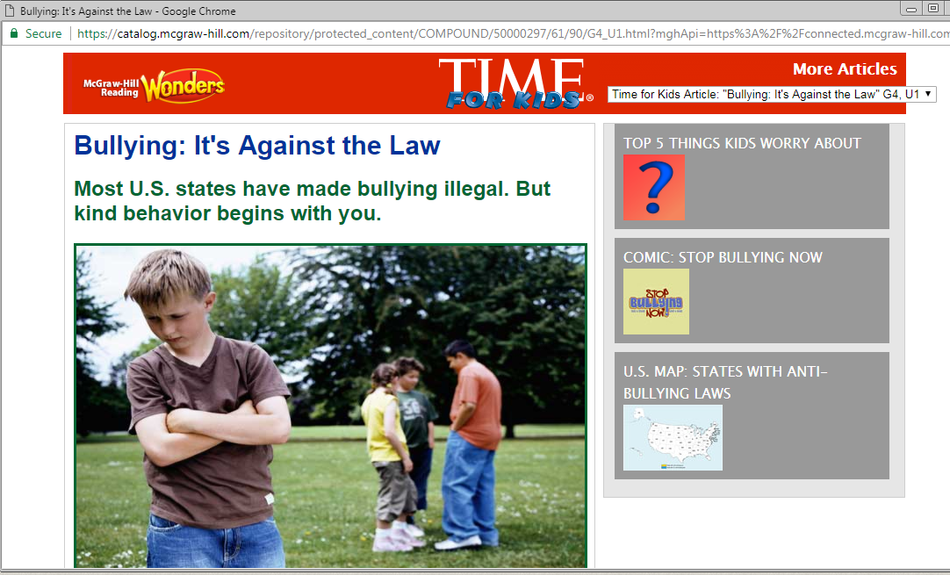

There are even Digital Performance Task that provide additional expository and informtion text for Inquiry. To access Inquiry Space at Grades 3-6, click Writing & Research > Research & Inquiry.

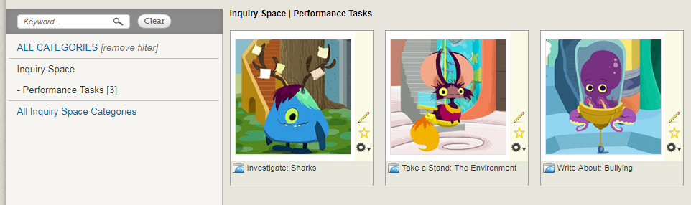

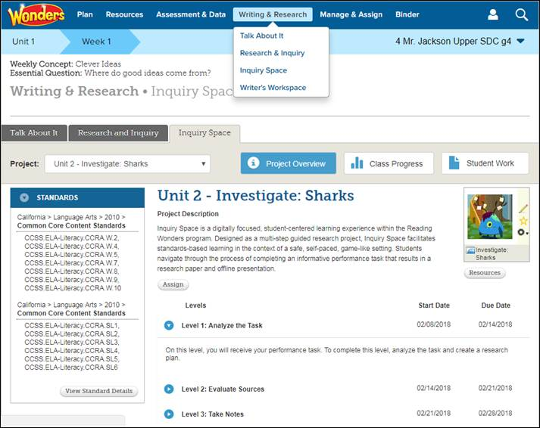

1. Wonders Online component for students especially on iPads is not working.  What will McGraw-Hill to address this issue?

McGraw-Hill Education is fully committed to replacing Flash content with HTML5-based content as quickly as possible. Given the scope of the Wonders programs we have undertaken this effort in phases, with full conversion expected by Spring of 2018.

To date, we have converted over 1000 of the program’s Leveled Readers to HTML5. We will complete conversion of the remaining eBooks by the end of October 2017.

Non-Flash versions of most assets already exist for iPad use. In a few cases (Grammonster), the non-Flash alternatives exist but are not being served; we’ll fix those quickly.

We have prioritized the remaining conversion and bug fixes along this timeline:

* Correction of Audio/Video player issues preventing launch of HTML5 versions (eBooks, Visual Vocab Cards) by the end of October.
* By December 2017, we will convert Wonders for English Learners, EL, WonderWorks, World of Wonders, and Maravillas assets.
* By April 2018, we will complete the remaining games and interactive activities.

We recognize the urgency of completing this conversion effort as soon as possible. We will accelerate any development we can, and we are actively monitoring reports to re-prioritize as needed. We’re also monitoring the ongoing updates to Chrome and other browsers to determine more efficient workarounds until the conversion effort is completed.

1. Please confirm that consumables will be available for 8 years with the adoption.  **Yes**
2. **PD plan will be provided**

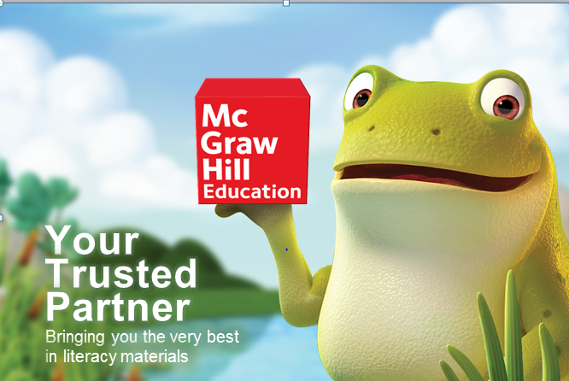

We appreciate you and thank you for your commitment to being a pilot teacher and look forward to providing you with support and guidance throughout the pilot process.

Best,

*Mia Gordon*

*McGraw-Hill Representative,*

*310-739-1827*

*mia.gordon@mheducation.com*